# OUTPUT DOCUMENT – LAB EXPERIMENTS

**NAME** : Kovi Sai Ganesh **REGISTER NUMBER** : 192124028 **COURSE CODE**: DSA0504

**COURSE NAME**: Query Processing for Data Science in Open Source Platform

1. Write a Pandas program to select distinct department id from employees file.

+ + + + + | DEPARTMENT_ID | DEPARTMENT_NAME | MANAGER_ID | LOCATION_ID | +--------

+ + + + | 10 |

Administration | 200 | 1700 | | 20 | Marketing | 201 | 1800 | | 30 |

Purchasing | 114 | 1700 | | 40 | Human Resources | 203 | 2400 | | 50 | Shipping | 121 | 1500 | | 60 | IT | 103 | 1400 | | 70 | Public Relations

| 204 | 2700 | | 80 | Sales | 145 | 2500 | | 90 | Executive | 100 | 1700

| | 100 | Finance | 108 | 1700 | | 110 | Accounting | 205 | 1700 | |

120 | Treasury | 0 | 1700 | | 130 | Corporate Tax | 0 | 1700 | | 140 | Control And Credit | 0 | 1700 | | 150 | Shareholder Services | 0 | 1700

| | 160 | Benefits | 0 | 1700 | | 170 | Manufacturing | 0 | 1700 | |

180 | Construction | 0 | 1700 | | 190 | Contracting | 0 | 1700 | | 200

| Operations | 0 | 1700 | | 210 | IT Support | 0 | 1700 | | 220 | NOC |

0 | 1700 | | 230 | IT Helpdesk | 0 | 1700 | | 240 | Government Sales |

0 | 1700 | | 250 | Retail Sales | 0 | 1700 | | 260 | Recruiting | 0 |

1700 | | 270 | Payroll | 0 | 1700 | +---------------+-----------------

+ +

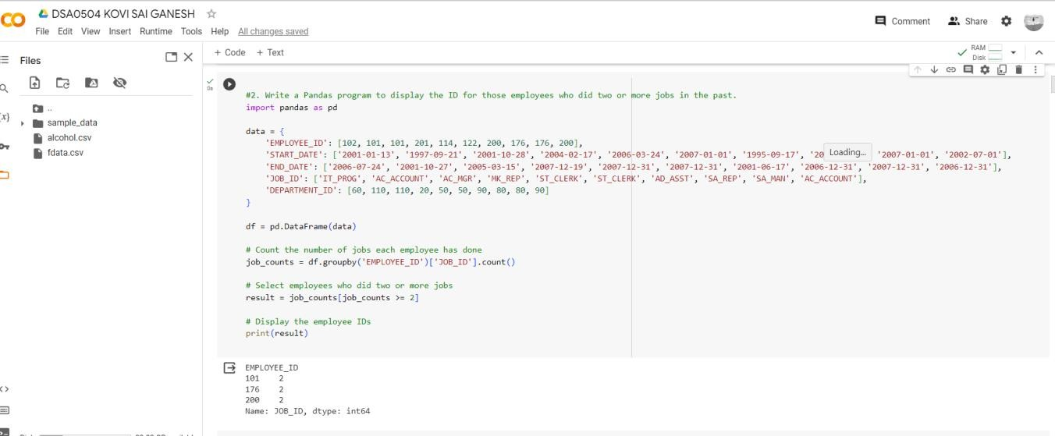

1. Write a Pandas program to display the ID for those employees who did two or more jobs in the past.

+ + + + + + | EMPLOYEE_ID | START_DATE | END_DATE | JOB_ID | DEPARTMENT_ID | +---------

+ + + + + | 102 | 2001- 01-13 | 2006-07-24 | IT_PROG | 60 | | 101 | 1997-09-21 | 2001-10-27 |

AC_ACCOUNT | 110 | | 101 | 2001-10-28 | 2005-03-15 | AC_MGR | 110 | | 201

| 2004-02-17 | 2007-12-19 | MK_REP | 20 | | 114 | 2006-03-24 | 2007-12-31

| ST_CLERK | 50 | | 122 | 2007-01-01 | 2007-12-31 | ST_CLERK | 50 | | 200

| 1995-09-17 | 2001-06-17 | AD_ASST | 90 | | 176 | 2006-03-24 | 2006-12-31

| SA_REP | 80 | | 176 | 2007-01-01 | 2007-12-31 | SA_MAN | 80 | | 200 |

2002-07-01 | 2006-12-31 | AC_ACCOUNT | 90 | +-------------+ +-



+ + +

1. Write a Pandas program to display the details of jobs in descending sequence on job title.

+ + + + + | JOB_ID | JOB_TITLE | MIN_SALARY | MAX_SALARY | +------------+-----------------

+ + + | AD_PRES | President | 20080 | 40000 | | AD_VP | Administration Vice President | 15000 | 30000 | | AD_ASST | Administration Assistant | 3000 | 6000 | | FI_MGR | Finance Manager | 8200 | 16000 | | FI_ACCOUNT | Accountant | 4200 | 9000 | | AC_MGR | Accounting Manager

| 8200 | 16000 | | AC_ACCOUNT | Public Accountant | 4200 | 9000 | | SA_MAN | Sales Manager | 10000 | 20080 | | SA_REP | Sales Representative | 6000 | 12008

| | PU_MAN | Purchasing Manager | 8000 | 15000 | | PU_CLERK | Purchasing Clerk

| 2500 | 5500 | | ST_MAN | Stock Manager | 5500 | 8500 | | ST_CLERK | Stock Clerk | 2008 | 5000 | | SH_CLERK | Shipping Clerk | 2500 | 5500 | | IT_PROG | Programmer | 4000 | 10000 | | MK_MAN | Marketing Manager | 9000 | 15000 | | MK_REP | Marketing Representative | 4000 | 9000 | | HR_REP | Human Resources Representative | 4000 | 9000 | | PR_REP | Public Relations Representative | 4500 | 10500 | + + + +

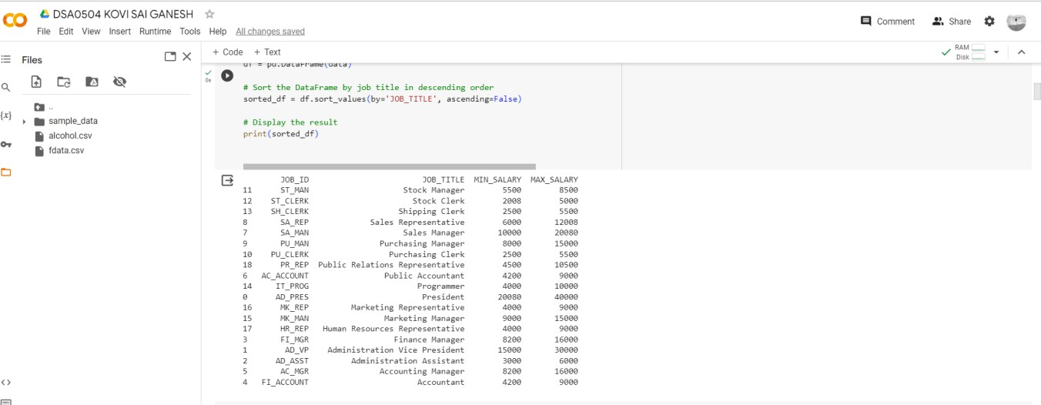

+

1. Write a Pandas program to create a line plot of the historical stock prices of Alphabet Inc. between two specific dates.
2. 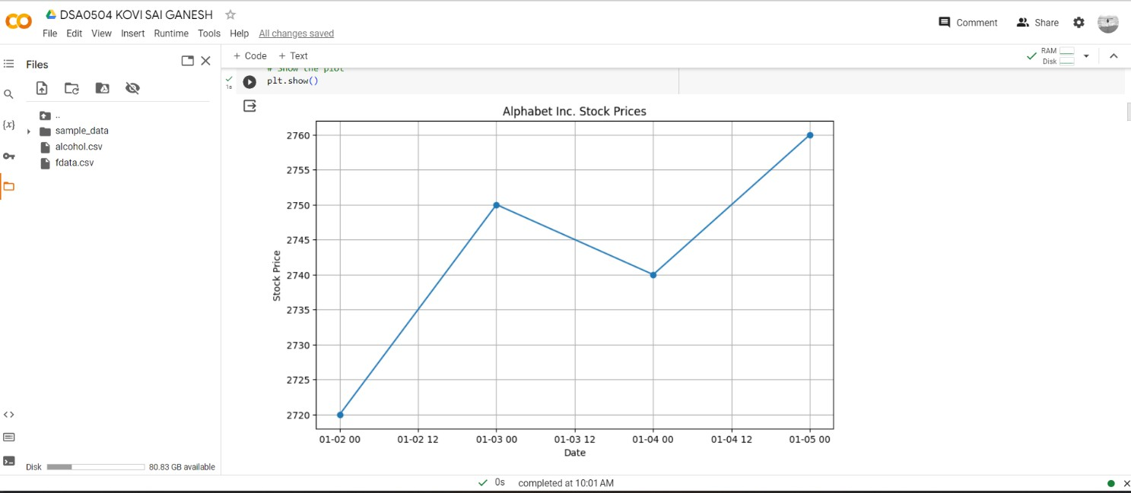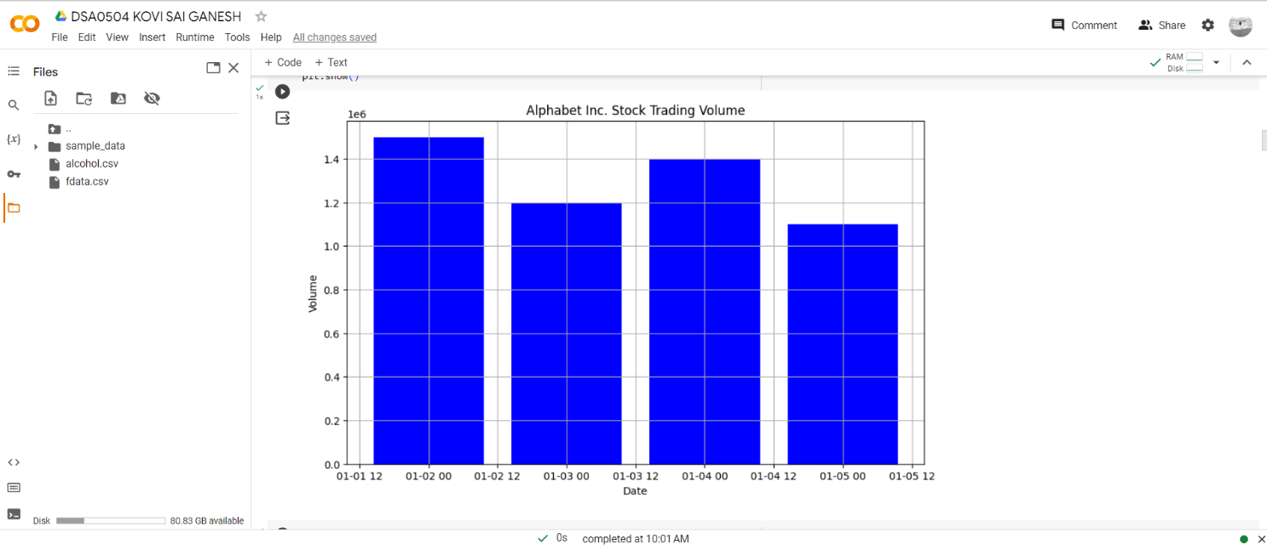Write a Pandas program to create a bar plot of the trading volume of Alphabet Inc. stock between two specific dates.
3. Write a Pandas program to create a scatter plot of the trading volume/stock prices of Alphabet Inc. stock between two specific dates. **alphabet_stock_data:**

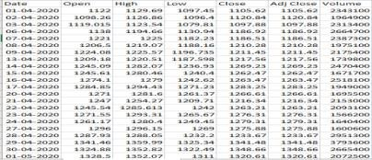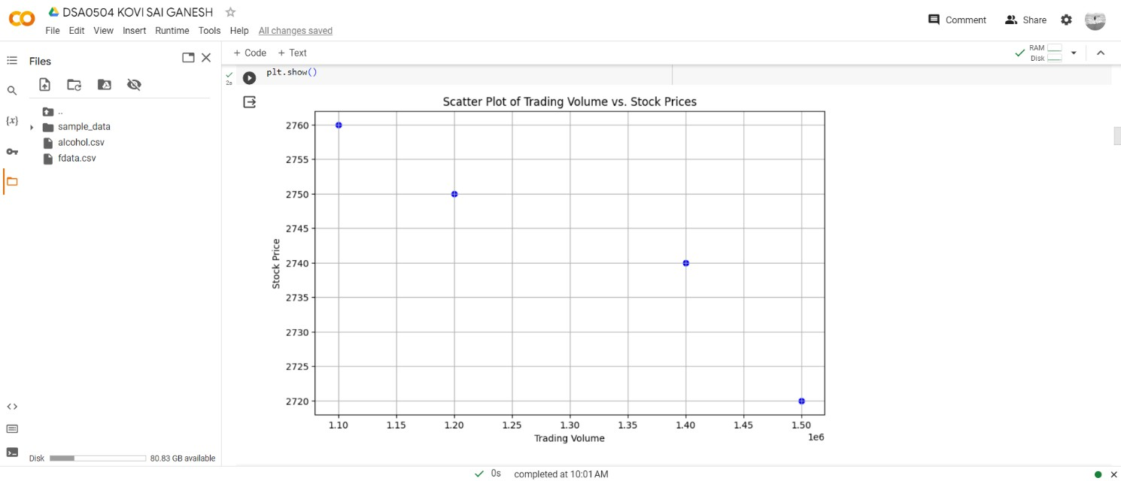

1. 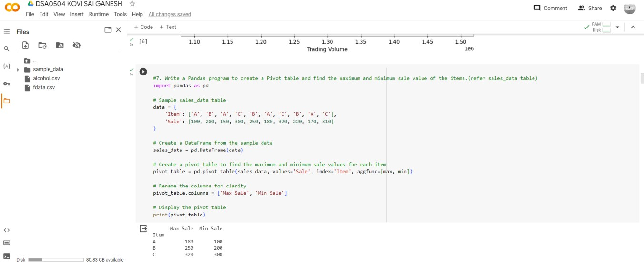Write a Pandas program to create a Pivot table and find the maximum and minimum sale value of the items.(refer sales_data table)
2. Write a Pandas program to create a Pivot table and find the item wise unit sold. .(refer sales_data table)

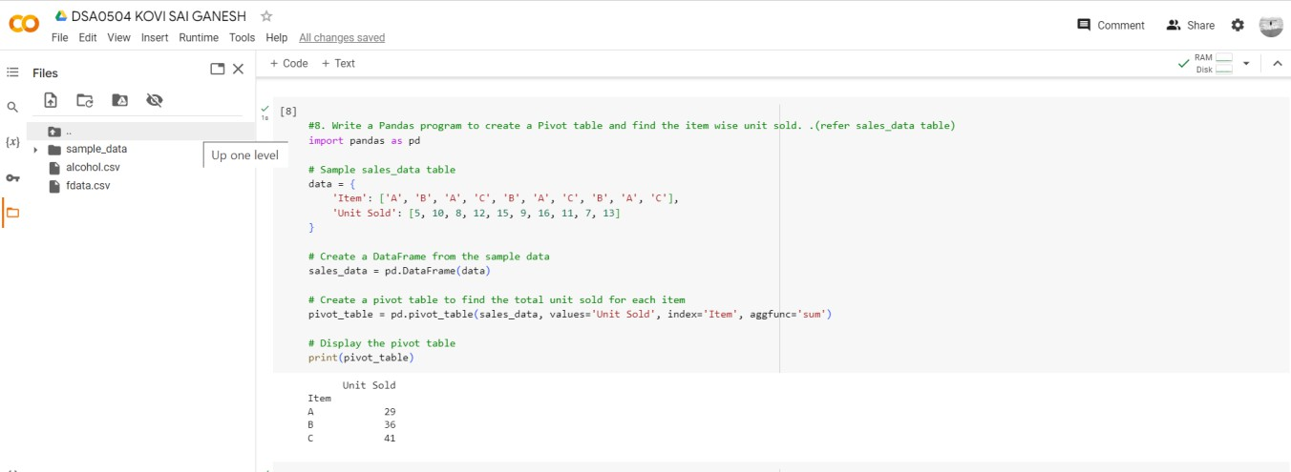

1. Write a Pandas program to create a Pivot table and find the total sale amount region wise, manager wise, sales man wise. .(refer sales_data table)

# Sales_data:

|  |  |  |  |  |  |
| --- | --- | --- | --- | --- | --- |
|  |  |  | **Item** |  |  |

**OrderDate Region Manager SalesMan Units Unit_price Sale_amt**

|  |  |  |  |  |  |
| --- | --- | --- | --- | --- | --- |
|  | |  | 95 |  | 1,198.00 |
| East | Martha |
|  |
|  | | | |

1-6-18 1,13,810.00

|  |  |  |  |  |  |
| --- | --- | --- | --- | --- | --- |
|  | nn Shelli |  | Home Theater | 50 | 500.00 |

1-23-18 25,000.00

|  |  |  |  |  |  |
| --- | --- | --- | --- | --- | --- |
|  | nn Luis |  | Televisi |  | 1,198.00 |
|  |

2-9-18 43,128.00

|  |  |  |  |  |  |
| --- | --- | --- | --- | --- | --- |
|  | Timothy |  | Cell Phone | 27 | 225.00 |

2-26-18 6,075.00

|  |  |
| --- | --- |
| West | Timothy |

|  |  |  |
| --- | --- | --- |
|  | Televisi |  |

1,198.00

3-15-18 67,088.00

|  |  |  |  |  |  |
| --- | --- | --- | --- | --- | --- |
| East | Martha | Alexand er | Home Theater | 60 | 500.00 |

4-1-18 30,000.00

|  |  |  |  |  |  |
| --- | --- | --- | --- | --- | --- |
|  |  | Steven | Televisi |  | 1,198.00 |
|  |

4-18-18 89,850.00

|  |  |  |  |  |  |
| --- | --- | --- | --- | --- | --- |
|  | nn Luis |  | Televisi |  | 1,198.00 |
|  |

5-5-18 1,07,820.00

|  |  |  |  |  |  |
| --- | --- | --- | --- | --- | --- |
| West | Dougla s | Michael | Televisi |  | 1,198.00 |
|  |

5-22-18 38,336.00

|  |  |  |  |  |  |
| --- | --- | --- | --- | --- | --- |
| East | Martha | Alexand er | Home Theater | 60 | 500.00 |

6-8-18 30,000.00

|  |  |  |  |  |  |
| --- | --- | --- | --- | --- | --- |
|  | nn Sigal |  | Televisi |  | 1,198.00 |
|  |

6-25-18 1,07,820.00

|  |  |  |  |  |  |
| --- | --- | --- | --- | --- | --- |
| East | Martha | Diana | Home Theater | 29 | 500.00 |

7-12-18 14,500.00

|  |  |
| --- | --- |
| East | Dougla s |

|  |  |  |  |
| --- | --- | --- | --- |
| Karen | Home Theater | 81 |  |
| 500.00 |
|  | | |

7-29-18 40,500.00

|  |  |  |  |  |  |
| --- | --- | --- | --- | --- | --- |
|  | |  | 35 |  | 1,198.00 |
| East | Martha |
|  |
|  | | | |

8-15-18 41,930.00

|  |  |  |  |  |  |
| --- | --- | --- | --- | --- | --- |
|  | Douglas | John | Desk | 2 | 125.00 |

9-1-18 250.00

|  |  |  |  |  |  |
| --- | --- | --- | --- | --- | --- |
| East | Martha | Alexand er | Video Games | 16 | 58.50 |

9-18-18 936.00

|  |  |  |  |  |  |
| --- | --- | --- | --- | --- | --- |
|  | nn Sigal |  | Home Theater | 28 | 500.00 |

10-5-18 14,000.00

|  |  |  |  |  |  |
| --- | --- | --- | --- | --- | --- |
| East | Martha | Alexand er | Cell Phone | 64 | 225.00 |

10-22-18 14,400.00



1. Create a dataframe of ten rows, four columns with random values. Write a Pandas program to highlight the negative numbers red and positive numbers black.

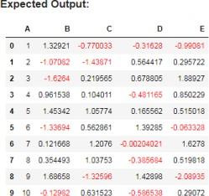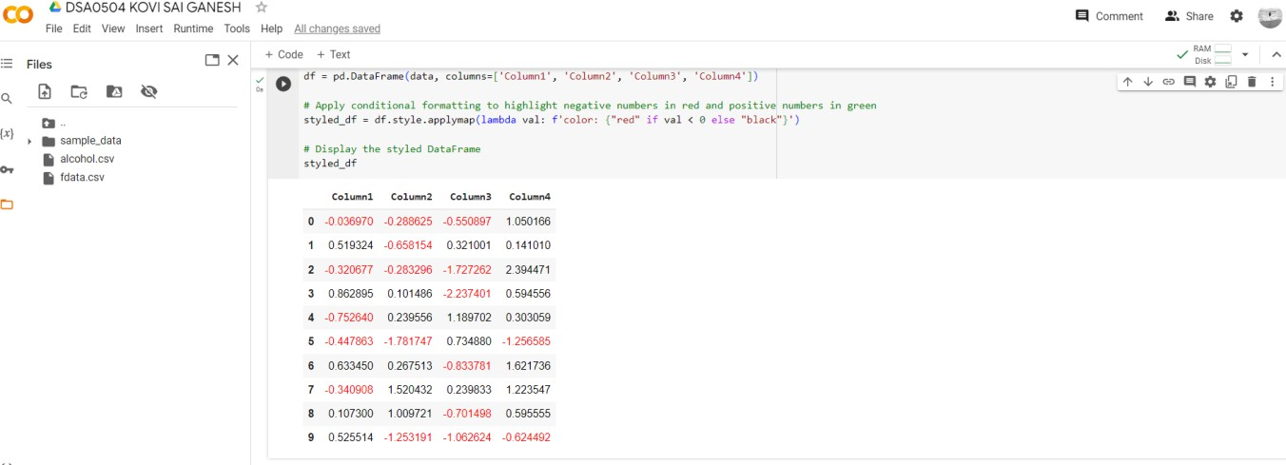

1. Create a dataframe of ten rows, four columns with random values. Convert some values to nan values. Write a Pandas program which will highlight the nan values.

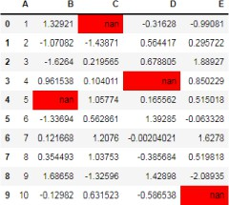

1. 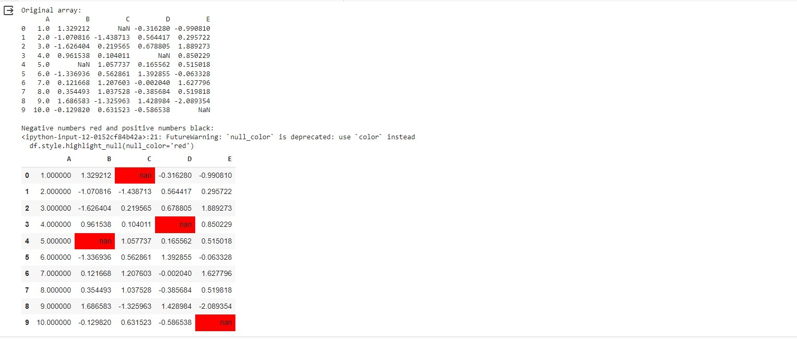Create a dataframe of ten rows, four columns with random values. Write a Pandas program to set dataframe background Color black and font color yellow.

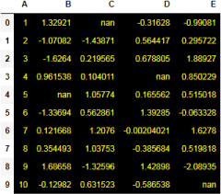

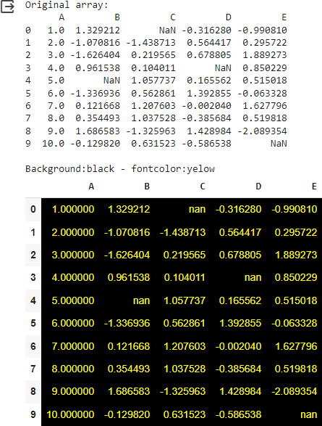

1. Write a Pandas program to detect missing values of a given DataFrame. Display True or False.

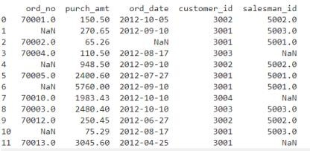

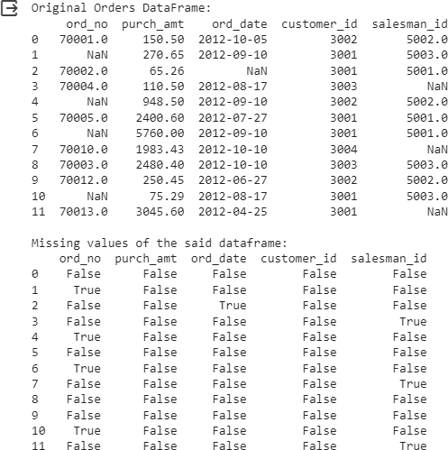

1. Write a Pandas program to find and replace the missing values in a given DataFrame which do not have any valuable information.

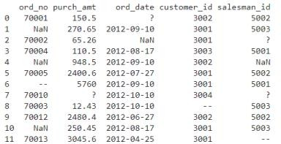

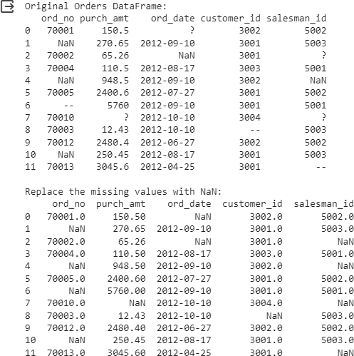

1. Write a Pandas program to keep the rows with at least 2 NaN values in a given DataFrame.

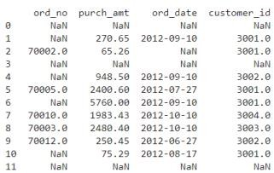

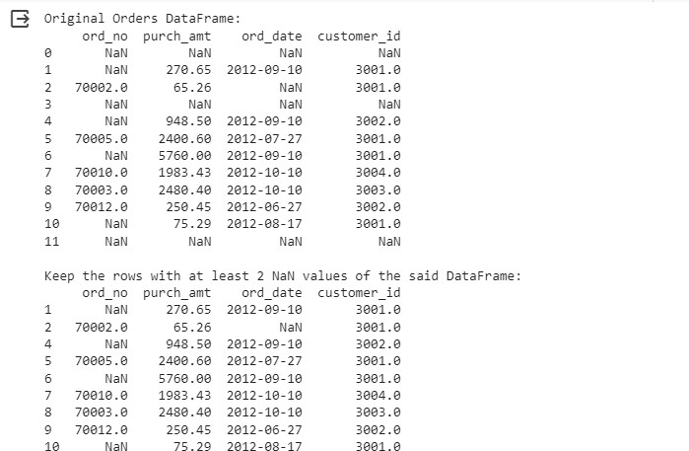

1. Write a Pandas program to split the following dataframe into groups based on school code. Also check the type of GroupBy object.

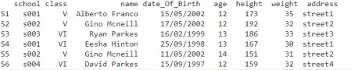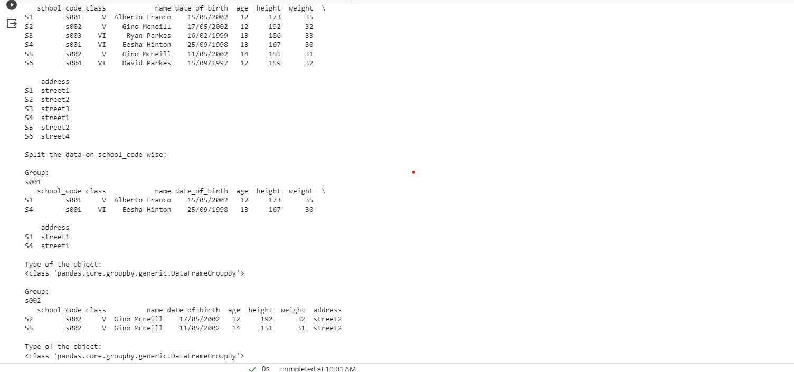

1. Write a Pandas program to split the following dataframe by school code and get mean, min, and max value of age for each school.

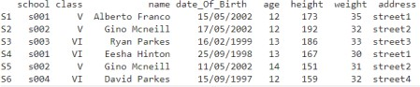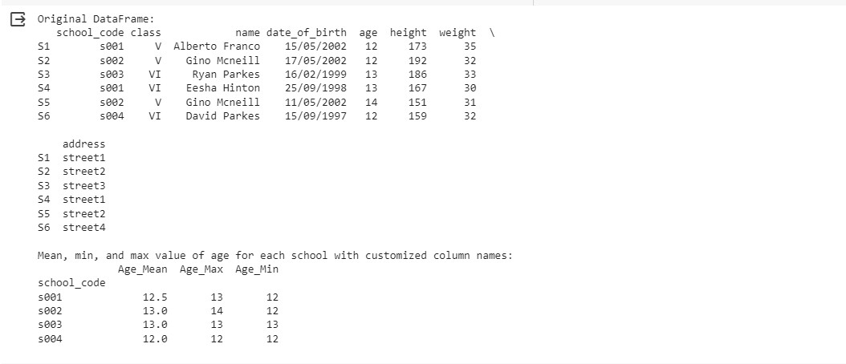

1. Write a Pandas program to split the following given dataframe into groups based on school code and class.

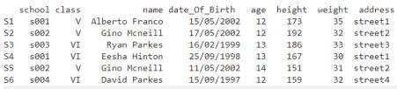

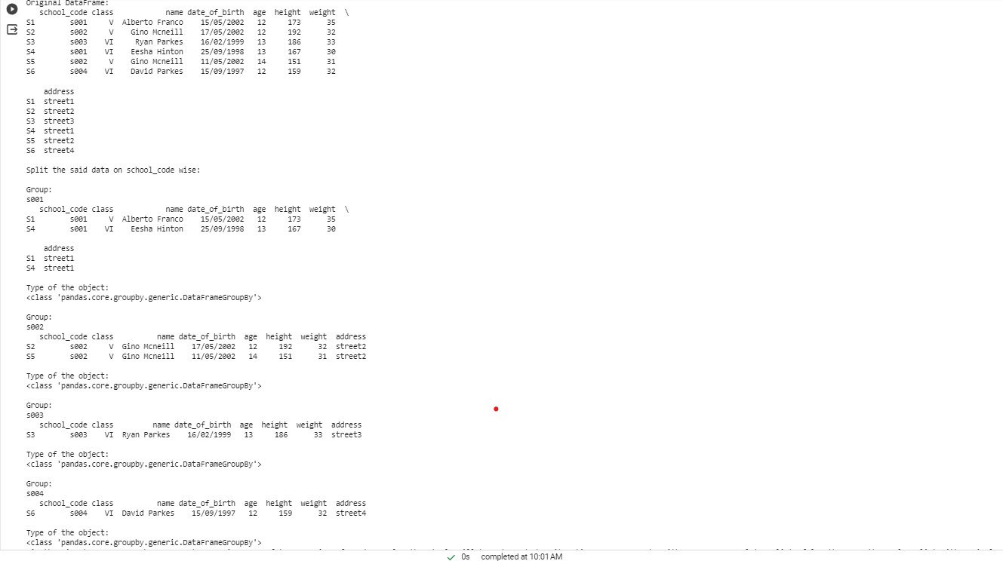

1. Write a Pandas program to display the dimensions or shape of the World alcohol consumption dataset. Also extract the column names from the dataset.

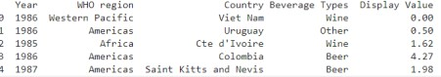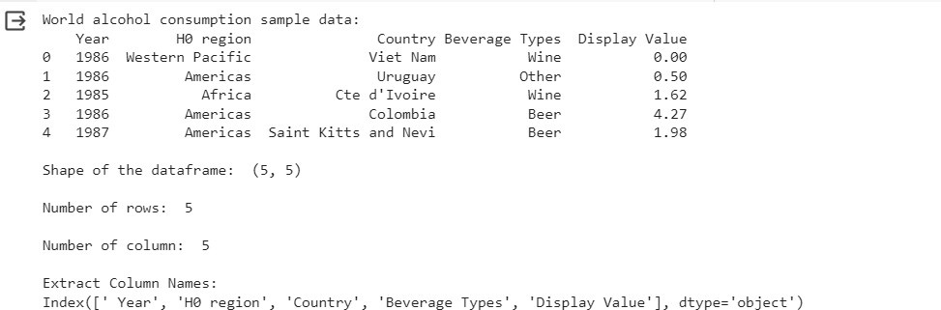

1. Write a Pandas program to find the index of a given substring of a DataFrame column.

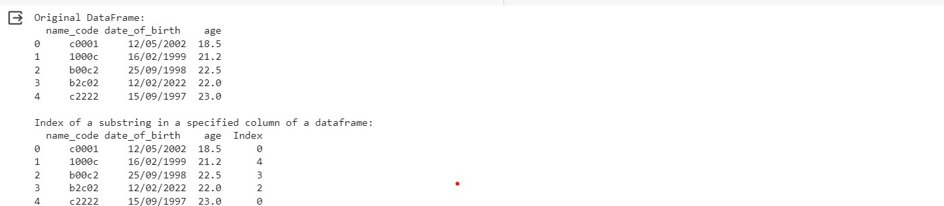

1. Write a Pandas program to swap the cases of a specified character column in a given DataFrame.

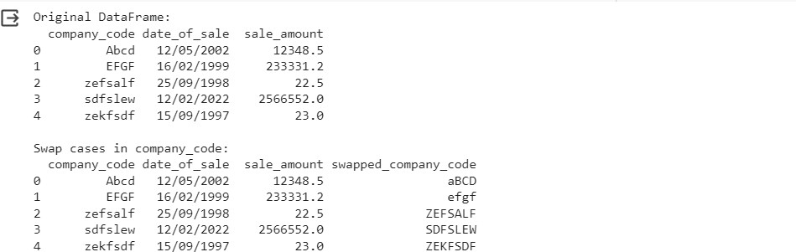

1. Write a Python program to draw a line with suitable label in the x axis, y axis and a title.

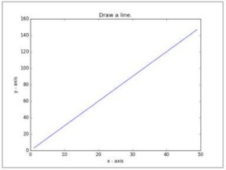

1. 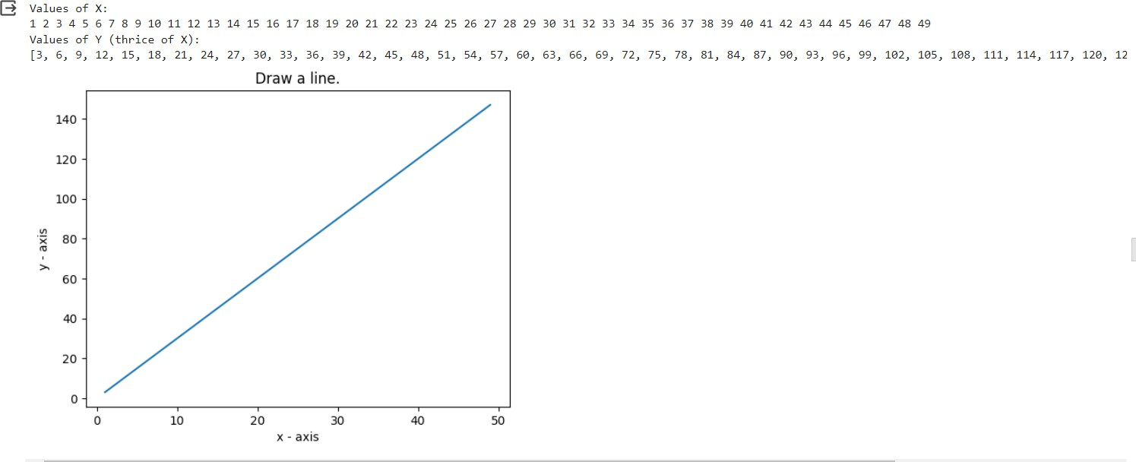Write a Python program to draw a line using given axis values taken from a text file, with suitable label in the x axis, y axis and a title.

*Test Data:*

test.txt

1 2

2 4

3 1

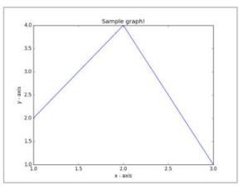

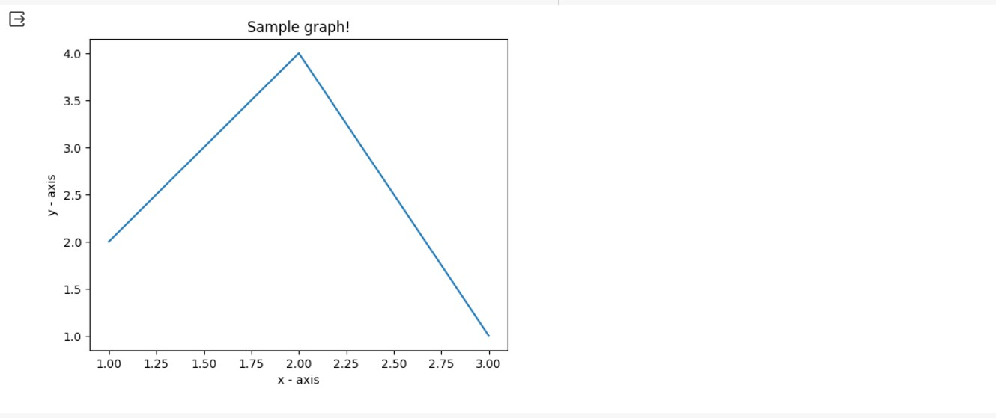

1. Write a Python program to draw line charts of the financial data of Alphabet Inc. between October 3, 2016 to October 7, 2016.

Sample Financial data (fdata.csv): Date,Open,High,Low,Close

10-03-16,774.25,776.065002,769.5,772.559998

10-04-16,776.030029,778.710022,772.890015,776.429993

10-05-16,779.309998,782.070007,775.650024,776.469971

10-06-16,779,780.47998,775.539978,776.859985

10-07-16,779.659973,779.659973,770.75,775.080017

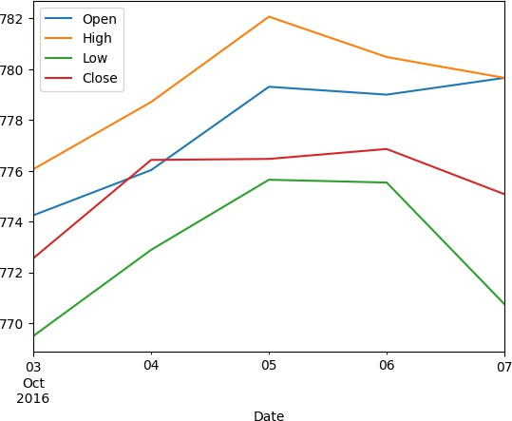

1. Write a Python program to plot two or more lines with legends, different widths and colors.

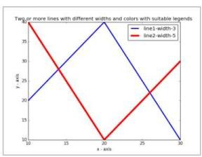

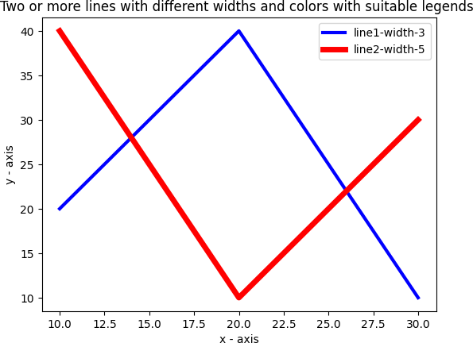

1. Write a Python program to create multiple plots.



1. Write a Python programming to display a bar chart of the popularity of

programming Languages. Sample data:

Programming languages: Java, Python, PHP, JavaScript, C#, C++ Popularity: 22.2, 17.6, 8.8, 8, 7.7, 6.7

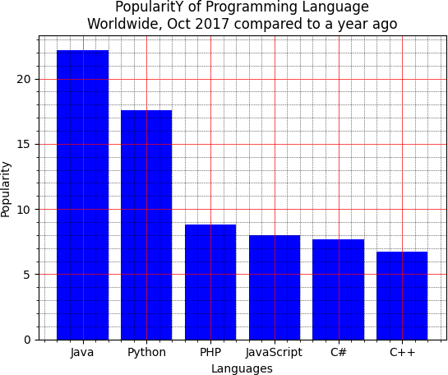

1. Write a Python programming to display a horizontal bar chart of the popularity of programming Languages.

Sample data:

Programming languages: Java, Python, PHP, JavaScript, C#, C++ Popularity: 22.2, 17.6, 8.8, 8, 7.7, 6.7

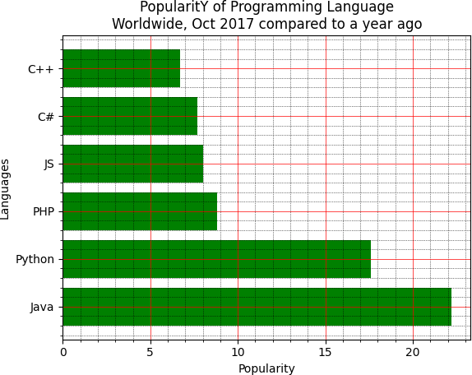

1. Write a Python programming to display a bar chart of the popularity of programming Languages. Use different color for each bar. Sample data: Programming languages: Java, Python, PHP, JavaScript, C#, C++ Popularity: 22.2, 17.6, 8.8, 8, 7.7, 6.7

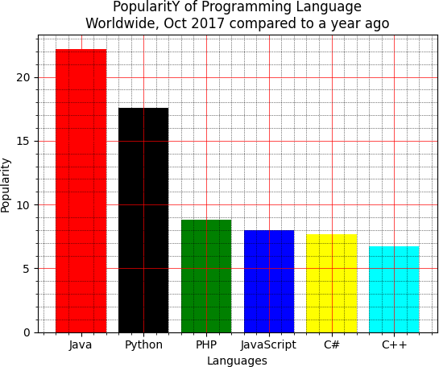

1. Write a Python program to create bar plot of scores by group and gender.

Use multiple X values on the same chart for men and women.

Sample Data:

Means (men) = (22, 30, 35, 35, 26)

Means (women) = (25, 32, 30, 35, 29)

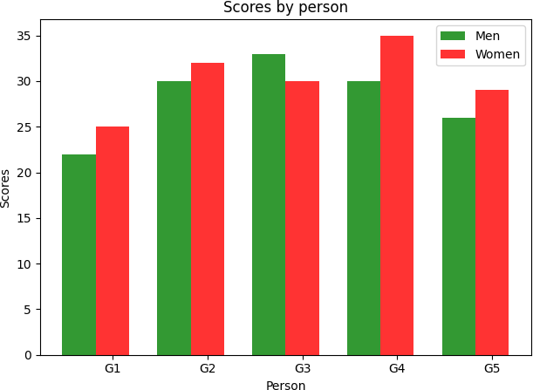

1. Write a Python program to create a stacked bar plot with error bars. Note: Use bottom to stack the women?s bars on top of the men?s bars. Sample Data:

Means (men) = (22, 30, 35, 35, 26)

Means (women) = (25, 32, 30, 35, 29)

Men Standard deviation = (4, 3, 4, 1, 5)

Women Standard deviation = (3, 5, 2, 3, 3)

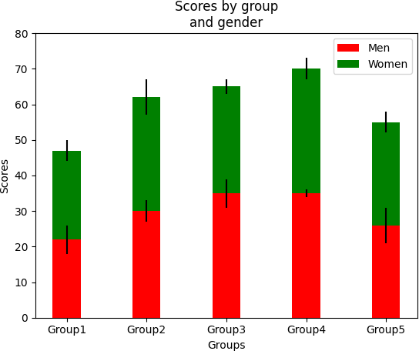

1. Write a Python program to draw a scatter graph taking a random distribution in X and Y and plotted against each other.



1. Write a Python program to draw a scatter plot with empty circles taking a random distribution in X and Y and plotted against each other.

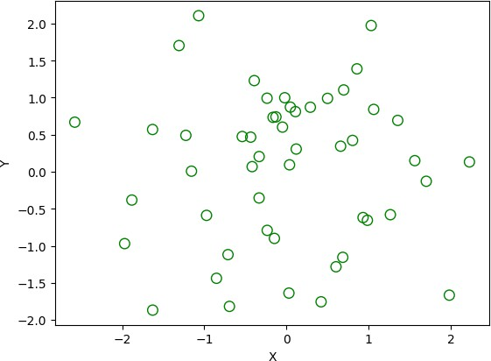

1. Write a Python program to draw a scatter plot using random distributions to generate balls of different sizes.

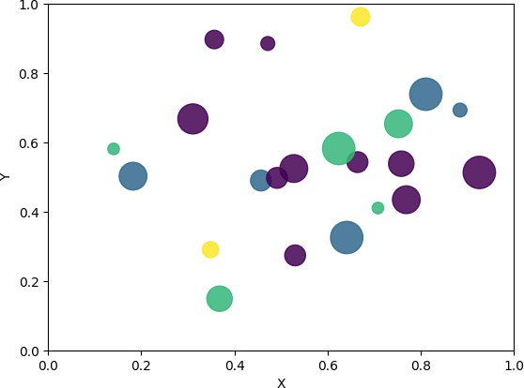

1. Write a Python program to draw a scatter plot comparing two subject marks of Mathematics and Science. Use marks of 10 students. Sample data:

Test Data:

math_marks = [88, 92, 80, 89, 100, 80, 60, 100, 80, 34]

science_marks = [35, 79, 79, 48, 100, 88, 32, 45, 20, 30]

marks_range = [10, 20, 30, 40, 50, 60, 70, 80, 90, 100]

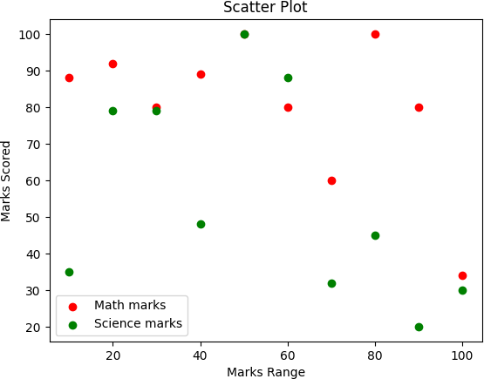

1. Write a Python program to draw a scatter plot for three different groups comparing weights and heights.

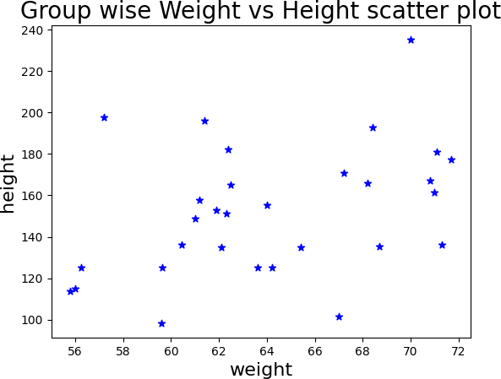

1. Write a Pandas program to create a dataframe from a dictionary and display it.

Sample data: {'X':[78,85,96,80,86], 'Y':[84,94,89,83,86],'Z':[86,97,96,72,83]}

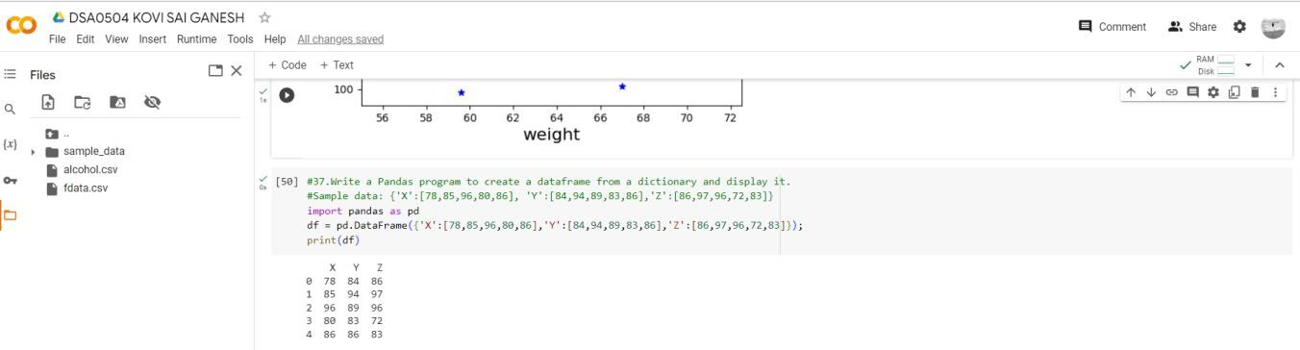

1. Write a Pandas program to create and display a DataFrame from a specified dictionary data which has the index labels.

Sample Python dictionary data and list labels:

exam_data = {'name': ['Anastasia', 'Dima', 'Katherine', 'James', 'Emily',

'Michael', 'Matthew', 'Laura', 'Kevin', 'Jonas'],

'score': [12.5, 9, 16.5, np.nan, 9, 20, 14.5, np.nan, 8, 19],

'attempts': [1, 3, 2, 3, 2, 3, 1, 1, 2, 1],

'qualify': ['yes', 'no', 'yes', 'no', 'no', 'yes', 'yes', 'no', 'no', 'yes']}

labels = ['a', 'b', 'c', 'd', 'e', 'f', 'g', 'h', 'i', 'j']

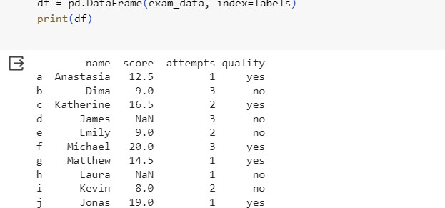

1. Write a Pandas program to get the first 3 rows of a given DataFrame. Sample Python dictionary data and list labels:

exam_data = {'name': ['Anastasia', 'Dima', 'Katherine', 'James', 'Emily',

'Michael', 'Matthew', 'Laura', 'Kevin', 'Jonas'],

'score': [12.5, 9, 16.5, np.nan, 9, 20, 14.5, np.nan, 8, 19],

'attempts': [1, 3, 2, 3, 2, 3, 1, 1, 2, 1],

'qualify': ['yes', 'no', 'yes', 'no', 'no', 'yes', 'yes', 'no', 'no', 'yes']}

labels = ['a', 'b', 'c', 'd', 'e', 'f', 'g', 'h', 'i', 'j']

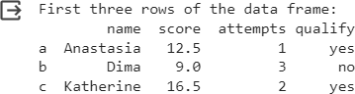

1. Write a Pandas program to select the 'name' and 'score' columns from the following DataFrame.

Sample Python dictionary data and list labels:

exam_data = {'name': ['Anastasia', 'Dima', 'Katherine', 'James', 'Emily',

'Michael', 'Matthew', 'Laura', 'Kevin', 'Jonas'],

'score': [12.5, 9, 16.5, np.nan, 9, 20, 14.5, np.nan, 8, 19],

'attempts': [1, 3, 2, 3, 2, 3, 1, 1, 2, 1],

'qualify': ['yes', 'no', 'yes', 'no', 'no', 'yes', 'yes', 'no', 'no', 'yes']}

labels = ['a', 'b', 'c', 'd', 'e', 'f', 'g', 'h', 'i', 'j']

